**Software Project Plan**

**Version 1.0**

**Project Management App**

**Team A**

**CSC-354**

**Fall 2015**

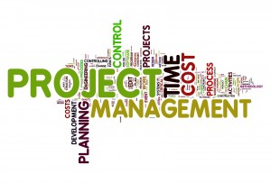

09/15/2015

Author: Tyler Mariano

Submitted To: Dr. Joo Tan

**Table of Contents**

Revision History…………………………………………………………………………………..ii

1.0 Introduction……..………………………………………………………………………….….1

1.1 Product Description…………………………………………………………………...1

1.2 Product Scope……………………………………………………….………………...2

1.3 Major Functions…………………………………………………………………….....2

1.3.1 Project Leader………………………………………………………….……2

1.3.2 Project Member………………………………………………….…………..2

1.4 User and User Environment…………………………………………………………...3

2.0 Project Estimates………………………………………………………………………………3

2.1 Historical Data………………………………………………………..……………….3

2.2 Effort Estimates……………………………………………………………………….3

2.3 Resources………………………………………………………..…………………….3

2.4 Project Feasibility…...…………………………………………..…………………….4

2.4.1 Economic Feasibility ……………………………...………………………..4

2.4.2 Development Costs………………………………………………………….4

2.4.3 Technical Feasibility……………………………………………………..….4

2.4.4 Schedule Feasibility ………………………………………………………...4

2.5 Team Structure…………………………………………………..…………………….5

3.0 Risk Management…………………………………………..…………………………………6

4.0 Project Schedule/Activities………………………………………………………………...….7

5.0 Tracking and Control Mechanism………………………………………………...…………..9

5.1 Version Control…………………………………………………………………….….9

5.2 Quality Assurance and Quality Control……………………………………………….9

6.0 Diagrams…………………………………………………………………………………..…10

6.1 Context Diagram……………………………………………………...………..…….10

6.2 System Architecture………………………………………………..………..……….11

7.0 Software Quality Attributes………………………………………………..………………...12

**REVISION HISTORY**

|  |  |  |  |
| --- | --- | --- | --- |
| Version | Author | Description | Date |
| 1.0 | Tyler Mariano | I created the first draft. | 09/07/2015 |
| 2.1 | Tyler Mariano | I made revisions based on the feedback from the first draft. My changes included… | 09/17/2015 |

**1.0 Introduction**

This project management application will be used for organizing, assigning, and tracking projects as they go through different phases of the development process. This project will be a mobile application and this document it will be used to inform its readers of the project’s cost, risks, functionalities, and structure.

**1.1 Project Description**

The Project Management App is an application that allows the user to track the progress of a project. In addition to that, the application allows the authorized user to add members and to keep track of the percentage of completion of the project. The user who creates the project is automatically assigned the leader role; which entitles the user the power to add and or delete members of the project. Once a project is created, each member is added by the leader. After being assigned to the project, they will receive a notification of whether he or she will accept the proposed project. Once the accepted request is received, the leader will be able to start delegating tasks to each member.

The main purpose of the leader role is to add, remove, and assign tasks to each member. He or she will be able to check the overall percentage of completion of the project and each individual member’s progress. Each assigned task should contain a task description, a due date, and a priority. Also, the leader is responsible for reviewing submitted tasks and reassigning them if there is some discrepancy between was expected and what was delivered.

The members can view their assigned tasks and submit the tasks once they are completed. However, they will not be able to view other members’ tasks. But, the project leader will have the capability to view each member’s individual progress and the overall progress of the project. Additional features of this application will give the users the capability to upload documents, view deadlines via calendar, instant message other team members via the app with questions, and assigning custom created member roles (designer, developer, manager, etc.).

**1.2 Project Scope**

We have high expectations for our project management mobile app. Our goal is to eventually have it available for download in the android app store. We are trying to make the app as universal as possible so it can be used to model any team projects scenarios in the real world.

This app will allow is user to create and join projects and add members to help complete the project. The leader can assign tasks with due dates, descriptions, and priority levels to the project members. The cost of creating apps for the android market is absolutely free. However, buying resources like books and/or videos on app creation may become necessary because this is such a complicated topic. Lastly, this project has a tentative deadline of May 2016.

**1.3 Major Functions**

This section describes the functionalities of the project leader and project member roles.

**1.3.1 Project Leader**

* The project leader can add/remove members.
* The project leader can assign tasks to the members.
* The project leader can add a description to each task.
* The project leader can add a due date to each task.
* The project leader can add a priority level to each task.
* The project leader can review each task.
* The project leader can also update each task as complete or incomplete.
* The project leader can reassign a task if it was not complete as expected.
* The project leader can create the project goal.
* The project leader can check the project’s progress and
* The project leader can check each member’s individual task progress as well.
* The project leader can update the progress of the project by marking tasks as complete.
* The project leader can set the project’s cost estimates.
* The project leader can create custom roles.

**1.3.2 Project Member**

* The project member can work on assigned tasks.
* The project member can join projects upon receiving an invite from the project leader.
* The project member can update their task’s progress.
* The project member can read their task’s descriptions.
* The project member can see their task’s due date via calendar view.
* The project member can view their task’s priority level.
* The project member can view their progress as a whole.
* The project member can message team members via the app messaging system.

**1.4 User and User Environment**

This application will be available on smartphone and tablets, but only for android powered devices. There will be no website to go along with this app at the moment it is mobile- exclusive (maybe a website could be looked into in the future). The user’s environment will be a clean and simple design that promotes work flow and allows members to update task swiftly as well as making assign tasks for the leader as unpretentious as possible.

**2.0 Project Estimates**

This section explains the functionalities of the project leader and project member roles.

**2.1 Historical Data**

None of the team members have any true app development experience on any platform.

**2.2 Effort Estimates**

Due to the android market place being free we plan to create this app using the newest android version Android 5.0, also known as Lollipop. There are fees and licenses that could apply depending on the app’s functionalities, but we have researched and there seems to always be a free alternative if you are willing to put the work in to understand the more complicated methods and do it yourself. Clearly, these free methods take more time to learn, but the cost it would save us is a much greater alternative.

**2.3 Resources**

Many resources will be used to help create this project. Our team currently consists of 3 computer science majors all with different talents in the project development field that complement each other nicely. The team has very little experience making mobile applications so we have been busy testing many IDE’s and android emulators to see what we will be most comfortable using. We have test Android Studios, Visual Studios 2015, IntelliJIDEA and Eclipse. We are willing to try others and even HTML 5 methods. We have also purchased books to help the team tackle this learning curve which is clearly the biggest current road block. Currently, we plan to use IntelliJIDEA and the Java programming language to create this project.

As far as hardware, two team members own Android powered devices and they are willing to use them to help expand our amount of testing platforms.

**2.4 Project Feasibility**

Below there are many different aspects of feasibility explained. Many real world aspects are not accounted for due to this being a school project.

**2.4.1 Economic Feasibility**

* The app will be sold for free with ads to make money.
* After researching many estimates it seems that ads on one app can make you $0.40 a day.
* Advertisement for ourselves can be spread for free with social media.
* There will also be a paid or pro version which user will have to pay $5.00 to download or upgrade to (this version comes without ads and special features).

**2.4.2 Development Costs**

* A real world computer science salary is $30 per hour. Since this is a school project this can be ignored and save room in our budget by have all the team members work for free!
* There is no app development fee through android, but we might run into a database license fee of $25.00.
* All equipment will be provided by the school for free.
* Our biggest cost is training. The learning curve for app development will take time and require us to purchase resources like textbooks to help speed up the process.
* The support staff will also work for free; however in the real world this would be just as costly as a salary expense ($30.00 per hour).

**2.4.3 Technical Feasibility**

* This project requires a lot of skills that none of the team members currently possess.
* We are well aware of this problem and plan to put the majority of our efforts into tackling this learning curve.
* We have begun researching the best languages and IDE for this project so all members can agree on the best course of action.

**2.4.1 Schedule Feasibility**

* By setting many maintainable goals we can break this huge project into smaller task to help tackle the problem.
* We will allow the most time for training. Once well trained the development should go smoothly, and faster.
* If the schedule does not go according to planned our mitigations in the risk management plan will help us get back on our feet.

**2.5 Team Structure**

The team structure consists of three members, each with two roles. The Roles are as follows: Project Leader, Project Manager, Systems Analyst, System Designer, System Developer, and System Tester. The only stipulations are that no team member may be both a System Developer and System Tester and the Project Leader is predetermined

|  |  |
| --- | --- |
| Team Member | Roles |
| Hector Richiez | Project Manager , System Developer |
| Jennifer Li | System Analyst, System Tester |
| Tyler Mariano | Project Leader, System Designer |

**3.0 Risk Management**

See Risk Management Plan, version 1.2, authored by Hector Richiez, dated September 8th, 2015

**4.0 Project Schedule/Activities**

Below is a table depicting the different phases of the project process. The tables consist of the name of the phase, the task to be accomplished or in process, the date due, estimated amount of days to complete the task, the status (completed or not completed), and the resources used.

|  |  |  |  |  |  |
| --- | --- | --- | --- | --- | --- |
| Phase | Task | Date Due | Est. (Days) | Status | Resources |
| 0-Planning | Define Project | 8/27 | 1 | Completed | All |
| Build project management application description | n/a | 1 | Completed | All |
| Team meeting with Dr. Tan | 09/01 | 1 | Completed | All |
| Work breakdown and team members role | 08/26 | 1 | Completed | All |
| Team Meeting (Platform targeted, technological constraints and selected tools for development) | 08/11 | 1 | Completed | All |
| 1-Technical Documents and Design | Build SRS (Software requirement specification) | n/a | 2 | Not Completed | All |
| Build RMP (Risk Management Plan) | 9/15 | 4 | Not Completed | :Hector Richiez  :Jennifer Li |
| Build SPP (Software Project Plan) | 9/17 | 6 | Not Completed | :Tyler Mariano |
| Build Quality Control and Assurance plan | TBD | 10 | Not Completed | All |
| Application Design | TBD | 7 | Not Completed | :Tyler Mariano |
| Build USD (Use Case Description/Use Case Diagrams) | TBD | 5 | Not Completed | All |
| Build HDL (High Level Diagrams) | TBD | 3 | Not Completed | All |
| Review USD and HDL for correctness and consistency | TBD | 2 | Not Completed | All |

|  |  |  |  |  |  |
| --- | --- | --- | --- | --- | --- |
| Phase | Task | Date Due | Est. (Days) | Status | Resources |
| 2-Implementation or Coding | User interface Development | TBD | 20 | Not Completed | :Hector Richiez  :Tyler Mariano |
| Messaging System development | TBD | 19 | Not Completed | :Hector Richiez  :Tyler Mariano |
| Database modeling design, coding and implementation | TBD | 10-15 | Not Completed | All |
| Develop Modular Testing | TBD | 3 | Not Completed | :Jennifer Li  :Tyler Mariano |
| Integrating Modules and Building Prototype for testing | TBD | 3 | Not Completed | :Jennifer Li  :Tyler Mariano |
| Application Completion | TBD | 5-10 | Not Completed | All |
| 3-Deployment | User Survey | TBD | 2 | Not Completed | All |
| Deployment of App in the android store | TBD | 1 | Not Completed | All |
| 4-Maintaince | Reworking coding logic functionality | TBD | 1 | Not Completed | All |
| Resolving Environmental or platform issues | TBD | ½ | Not Completed | All |
| Addressing user’s feedback | TDB | 1-5 | Not Completed | All |

**5.0 Tracking and Control Mechanisms**

Below are sections relating to how we plan on releasing the newest versions of our software to our customers. It also explains how we maintaining a certain level of quality for our app’s users.

**5.1 Version Control**

* Multiple back-ups will be held to prevent loss of data.
* Systems like GIT may be implemented to allow for saved repositories.
* GIT also allows for better new feature integration without overwriting pervious data.
* New releases will be made available through the android marketplace.
* New versions will come with vivid descriptions of new features, bug fixes, and improvements.
* Different versions of the software will still allow for seamless communication so not everyone is forced to the newest version if they don’t want to be.

**5.2 Quality Assurance and Quality Control**

* Using the android marketplace review system we will be able to see customers a real time evaluation of our customers feedback.
* The app will ask for the user to rate the app after it has been open for the 5th time.
* The reviews will be used to determine what aspects of the application need to be fixed, added, or improved upon.
* Ensure mitigation plans are followed as depicted in the risk management plan.
* Set hours will be established and documented for each team member to show fixes, improvements, or new features they have added to progress the app.
* Changing the app based on customer feedback is the best way to ensure we produce the best possible quality app for our users.

**6.0 Diagrams**

Below are two sections describing the context diagram and the system architecture. The context diagram shows the flow that this application’s users are supposed to follow.

**6.1 Context Diagrams**

* This context diagram explains how the project, project leader, and project members are all supposed interact.
* Leaders and members can only exist if a project does.
* It also explains all the different things the leader and member can do.
* Lastly, it states the components of the project.

Project Management

System

Members

Leader

Add/Remove Members

Assign Tasks

Project

Goals

Description

Submit Tasks

Update Progress

Review Submitted Tasked

Progress

Cost

Re-assign Tasks

Messaging

**6.2 System Architecture**

* Users can download the app via the Android market place.
* Users can access the application via their mobile devices (cell phone or tablet).
* Databases will be used to store all projects (projects consist of leaders and members).



Download project management app from app store

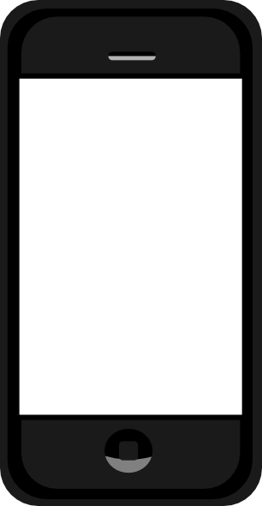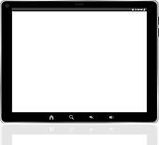

Available for smart phone and tablets (Android only)



Create account then log into project management app

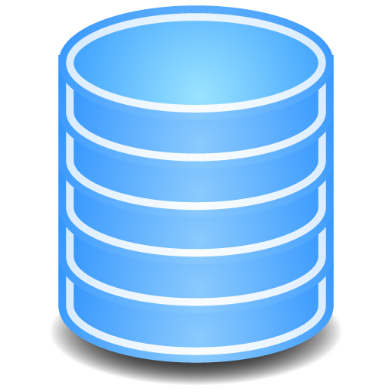

Project Database



Member Database

Leader Database

**7.0 Software Quality Attributes**

Software quality attributes must be based on reliability, usability, and scalability. To test reliability we will examine the threshold of the app buy adding projects, members, and tasks until it crashes. By measuring the amount of data each user before it crashes will allow us to cap the amount of projects, members, and tasks so the app never fails. Also, buy viewing user feedback and updating user found issues quickly this will be an app customers can depend on. As far as usability, we hope that this app will be used in multiple project seniors ranging from simple software teams to large scale architecture projects. This app is meant to organize and structure teams and will be applicable to any field! There are currently no plans of making this application web based or expanding to other platforms. Therefore, is scalability is limited to Android powered smartphones and tablets.